Experiment – 9.1.2
Palindrome or Not
- Algorithm
  - Start
  - Read string X
  - Find reverse of X and store in variable reverse
  - Compare X with reverse
  - If X == reverse
  - Print "Palindrome"
  - Else
  - Print "Not a Palindrome"
  - Stop

- Flowchart :
- Code :
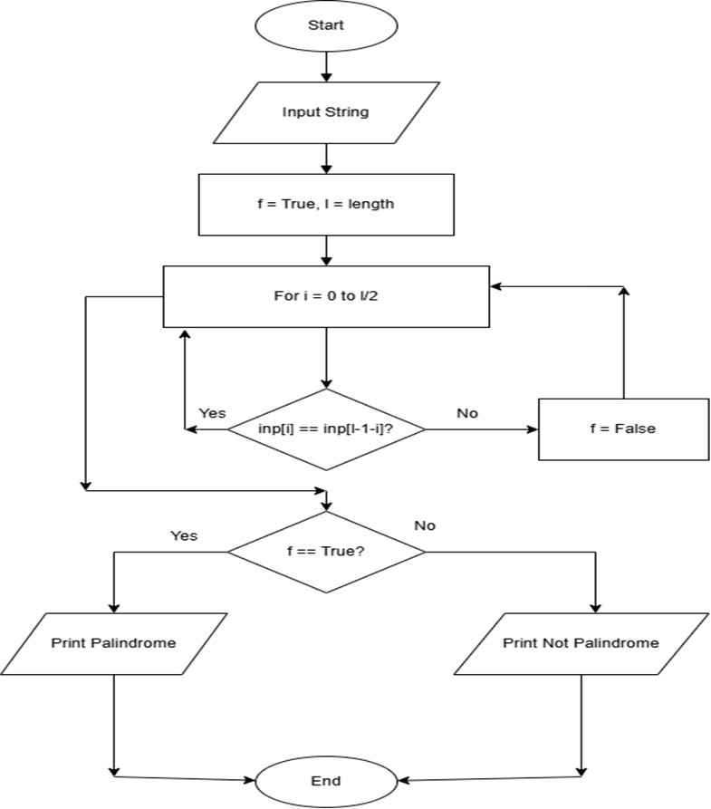
str = input() l=len(str) flag=True for i in range(l):
if str[i]!=str[l-1-i]:
flag= False
if flag:
print("Palindrome") else:
print("Not a Palindrome")

- Execution : 